Application Gateway

Azure Application Gateway is a web traffic (OSI layer 7) load balancer that enables you to manage traffic to your web applications. Traditional load balancers operate at the transport layer (OSI layer 4 - TCP and UDP) and route traffic based on source IP address and port, to a destination IP address and port.
Application Gateway can make routing decisions based on additional attributes of an HTTP request, for example URI path or host headers. For example, you can route traffic based on the incoming URL. So if /images is in the incoming URL, you can route traffic to a specific set of servers (known as a pool) configured for images. If /video is in the URL, that traffic is routed to another pool that's optimized for videos.

Azure Application Gateway is a Layer 7 load balancer that manages HTTP and HTTPS traffic. It offers application-level routing and features like SSL termination, URL-based routing, session affinity, and Web Application Firewall (WAF) integration. It is ideal for delivering high availability and centralized protection for web applications.
SSL termination, URL-based routing, session affinity, and Web Application Firewall (WAF), Autoscaling, Zone redundancy, Ingress Controller for AKS, Multiple-site hosting

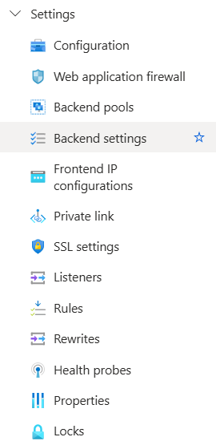

Secure Sockets Layer (SSL/TLS) termination
Application gateway supports SSL/TLS termination at the gateway, after which traffic typically flows unencrypted to the backend servers. This feature allows web servers to be unburdened from costly encryption and decryption overhead.
Autoscaling
Application Gateway Standard_v2 supports autoscaling and can scale up or down based on changing traffic load patterns. Autoscaling also removes the requirement to choose a deployment size or instance count during provisioning
Zone redundancy
A Standard_v2 Application Gateway can span multiple Availability Zones, offering better fault resiliency and removing the need to provision separate Application Gateways in each zone.
Ingress Controller for AKS
Application Gateway Ingress Controller (AGIC) allows you to use Application Gateway as the ingress for an Azure Kubernetes Service (AKS) cluster.
The ingress controller runs as a pod within the AKS cluster and consumes Kubernetes Ingress Resources and converts them to an Application Gateway configuration, which allows the gateway to load-balance traffic to the Kubernetes pods.
URL-based routing
URL Path Based Routing allows you to route traffic to backend server pools based on URL Paths of the request. One of the scenarios is to route requests for different content types to different pool.
For example, requests for http://contoso.com/video/* are routed to VideoServerPool, and http://contoso.com/images/* are routed to ImageServerPool. DefaultServerPool is selected if none of the path patterns match.
Multiple-site hosting
With Application Gateway, you can configure routing based on host name or domain name for more than one web application on the same application gateway. It allows you to configure a more efficient topology for your deployments by adding up to 100+ websites to one application gateway. Each website can be directed to its own backend pool
Redirection
A common scenario for many web applications is to support automatic HTTP to HTTPS redirection to ensure all communication between an application and its users occurs over an encrypted path
Session affinity
The cookie-based session affinity feature is useful when you want to keep a user session on the same server. Using gateway-managed cookies, the Application Gateway can direct subsequent traffic from a user session to the same server for processing. This is important in cases where session state is saved locally on the server for a user session.

3. Web Application Firewall (WAF)
Provides centralized protection from common exploits and vulnerabilities:
- Modes: Detection (logs only) or Prevention (actively blocks)
- Rule Sets: OWASP (3.0, 3.1, etc.)
- Custom Rules: Based on IPs, geolocation, header values, etc.
Use Case: Preventing SQL injection or XSS attacks.
Features
- SQL injection protection.
- Cross-site scripting protection.
- Protection against other common web attacks, such as command injection, HTTP request smuggling, HTTP response splitting, and remote file inclusion.
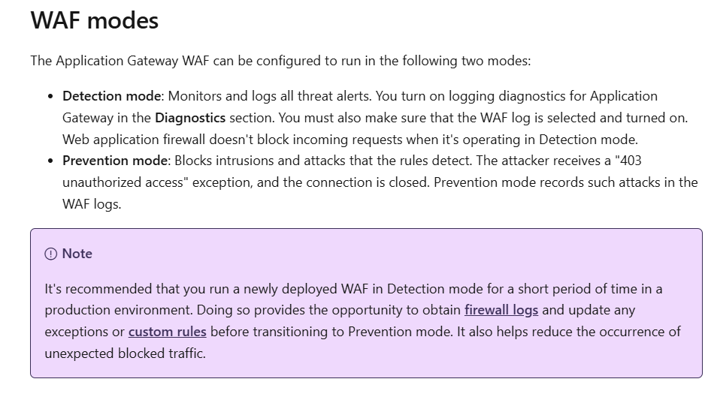
4. Backend Pools
A group of servers that serve the application content.
- Can include IPs, NICs, or FQDNs (e.g., webservers)
Use Case: Routing traffic to a VM Scale Set or App Service.
5. Backend Settings
Defines how Application Gateway connects to the backend:
- Protocol: HTTP/HTTPS
- Port
- Cookie-based affinity
- Timeout
- Custom probe association
Use Case: Ensuring sticky sessions for user logins.
6. Frontend IP Configurations
Defines the entry point of your Application Gateway:
- Public IP or Private IP
Use Case: Private IP for internal-only access (e.g., inside a VNet).

7. Private Link
Allows secure access to backend services over a private endpoint.
- Connects App Gateway to services like Azure SQL, Storage, etc.
Use Case: Restricting App Gateway to talk to backend over Azure backbone.

8. SSL Settings
Manages certificates and SSL termination:
• SSL certificates for frontend HTTPS listeners.
• Enables SSL termination and end-to-end encryption.
• Supports re-encryption to backend.

9. Listeners
Accept incoming traffic:
- Protocol (HTTP/HTTPS)
- Port (usually 80/443)
- Frontend IP
- SSL certificate (for HTTPS)
Use Case: One listener per website hosted via multi-site routing.

10. Rules
Defines how the listener maps to backend pools:
- Basic Rule: One-to-one mapping (frontend to backend)
- Path-based Rule: Route based on URL paths (e.g., /api → API pool)
Use Case: Hosting multiple applications on one gateway.

11. Rewrites
Modify request/response headers:
- Add/remove/modify headers
- Rewrite URLs (v2 SKU only)
Use Case: Add a custom header for security policies or to direct traffic.

Health Probes
- Continuously monitor the health of backend instances.
- Probes define protocol, port, and path to check.

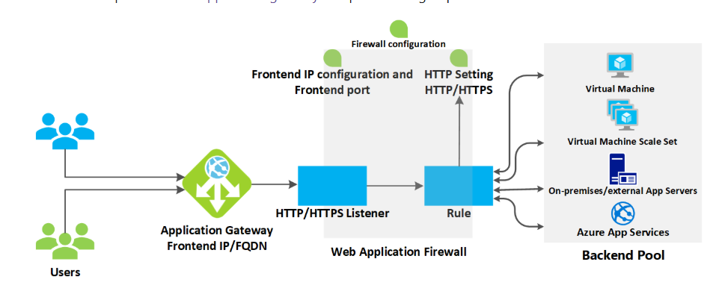

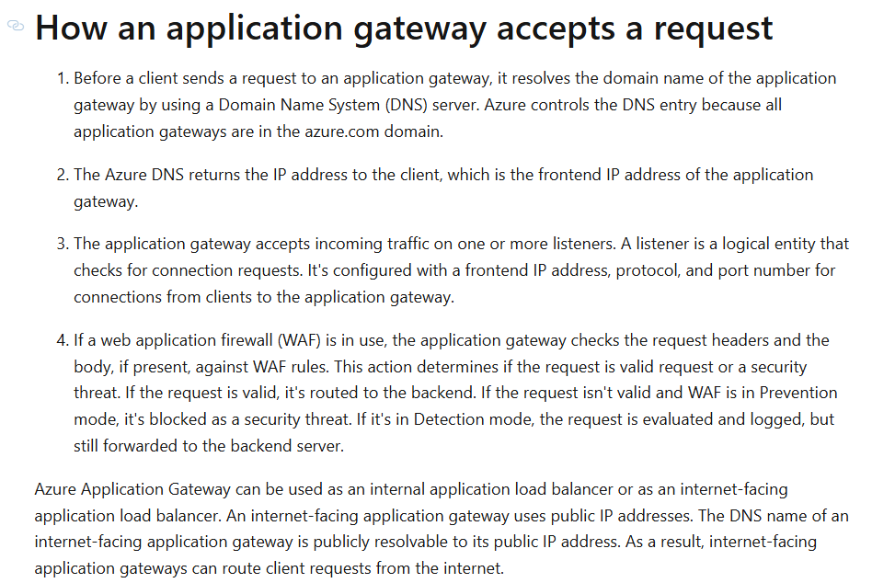
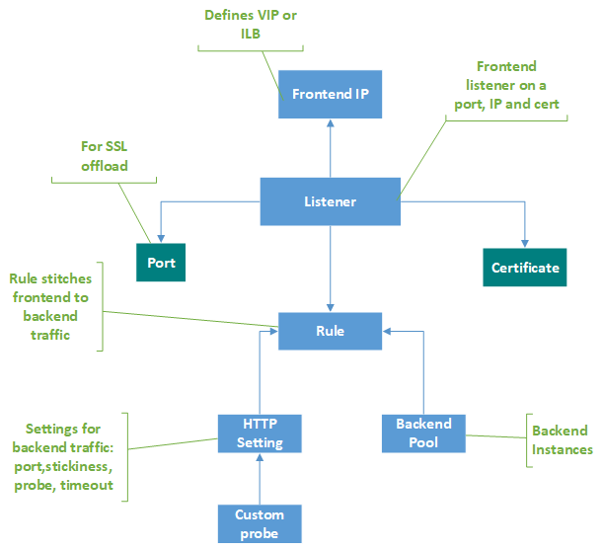

Request Flow (Detailed Step-by-Step)

🔹 Step 1: Request Hits the Frontend IP Address
- The incoming request is made to the public or private IP address of the Application Gateway, depending on how it is configured.
- IP types:
  - Public IP: Internet-facing
  - Private IP: Internal VNet access only

🔹 Step 2: Listener Captures the Request
- A listener listens for incoming requests on a specific IP, port, and protocol (e.g., HTTPS on port 443).
- It includes:
  - Frontend IP (public/private)
  - Protocol (HTTP/HTTPS)
  - Host name (optional for multi-site routing)
  - SSL certificate (if HTTPS)

🔹 Step 3: Web Application Firewall (WAF) Processing
- If WAF is enabled, the listener passes the request to the WAF module.
- WAF performs:
  - Signature-based checks (OWASP rules)
  - IP restrictions
  - Geolocation checks
- Modes:
  - Detection – Logs only
  - Prevention – Blocks malicious requests
🔸 Important: WAF works before routing the request to the backend.

🔹 Step 4: Request Routing Rules
- These define how the request should be routed based on the URL, headers, and hostname.
- Routing types:
  - Basic – Routes all requests to a single backend
  - Path-based – Routes requests to different backends based on the URL path
  - Multi-site – Routes based on the host header
Routing rules tie together:
- Listener
- Backend pool
- Backend settings
- Optional rewrites

🔹 Step 5: Backend Settings
- These settings define how to connect to the backend:
  - HTTP/HTTPS protocol
  - Port number
  - Timeout settings
  - Trusted root certificates for SSL backend verification
  - Cookie-based affinity (session persistence)
  - Connection draining (graceful shutdown)

🔹 Step 6: Health Probes
- Before forwarding the request, Application Gateway checks health probe results to see which backend instances are healthy.
- If the target backend is healthy, the request proceeds.
- If not, it skips unhealthy instances.

🔹 Step 7: Forwarding to Backend Pool
- Finally, the request is sent to one of the backend pool members (e.g., Azure VMs, VMSS, App Services, etc.).
- Load balancing happens between healthy targets in the backend pool.

✅ Summary (Interview-Ready Notes)
Component | Description
Frontend IP | Entry point (public/private) for external/internal requests
Listener | Binds IP + Port + Protocol; intercepts incoming traffic
WAF (optional) | Inspects request for malicious patterns before forwarding
Routing Rules | Directs traffic to the correct backend pool based on URL, host, etc.
Backend Settings | Defines protocol, port, SSL settings, session persistence, etc.
Health Probes | Ensures backend targets are healthy before sending requests
Backend Pool | Final destination: VMs, VMSS, App Services, or other compute resources

